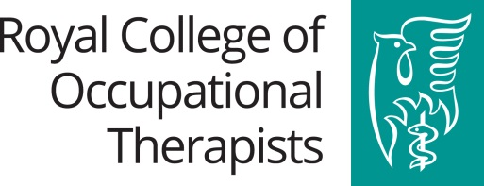
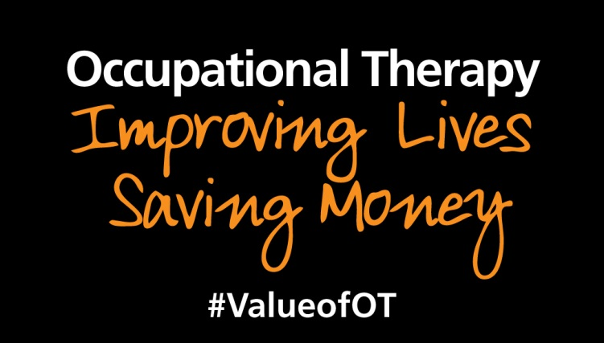

How to demonstrate the impact of occupational therapy in mental health

Name of service and location (please include country)
Description of the service:
e.g. the service purpose, profile of users, setting, integrated/multidisciplinary, seven day etc.
The challenge:
Where was the gap in service delivery? What need was the service set up to meet? What challenge does your service address?

Actions taken: e.g. aims of service, delivery, assessments and measures used
Tell us what you/your service did and how you now deliver occupational therapy e.g. assessments, interventions and measures used. These may include:
- changes in how you work with partners and liaise with other agencies,
- changes in how you offer access to occupational therapy,
- have repositioned the role of occupational therapy ,
- how occupational therapy is now delivered
- co-production, community assets based approach
- working with carers
Impact: e.g. Difference to service users, carers, systems delivery, other services and delivery partners.
What has been the difference to service user’s experience of referral and working with the service?
Have new pathways been developed, new partnerships or communities of practice formed?
Has there been a difference to the local community?

Describe the outcomes of your interventions and/or the outcomes of your service. Outcomes demonstrate changes. Outcomes may reflect improvement, maintenance or prevention of deterioration.

Proxy outcomes will include avoidable use of services for example: reduced hospital admissions and care home placements.

Outcome measures commonly used include:
- MOHO tools (Model of Human Occupation),
- Assessments Health of the Nation Outcome Scales (HoNOS),
- EQ-5D,
- Canadian Occupational Performance Measure (COPM),
- Australian Therapy Outcome Measures (AusTOMs),
- Assessment of Motor and Process Skills (AMPS)
- Goal Attainment Scale (GAS)
Measure of success: Improvements to service users - occupational outcomes, health and wellbeing outcomes - mental and physical health benefits, social engagement, ability to self manage.
Value to the carer(s) and improvements to service delivery (quality of care outcomes)
Costs savings/return on investment

There are different types of outcomes to be considered: Occupational outcomes, Health and Well Being outcomes and Quality of Care outcomes.

- Occupational Outcomes may capture improvements in relation to:
- The number of occupational goals achieved
- A person’s confidence and ability to continue with occupations
- Independence- reduced dependency on others to carry out occupations
- Ability to return to roles

- Health and wellbeing outcomes may capture improvements in relation to:
- Occupations the person is now able to engage in
- Ability to maintain roles
- Return or ability to stay in work
- Ability to access family, friends and communities
- Person’s perceived ability to manage their illness
- Person’s experience and ability to cope –PREMs
- Value to the carer

This is usually reported through Qualitative data. It can also be captured through Quantitative data i.e.- the numbers and percentages of:
- Outcomes set by the person achieved
- People completing intervention/ reaching goals
- People discharged from the service

- Quality of Care Outcomes may capture improvements to:
- Value of the service to the person- PROMs
- Value of the service to the carer
- Communication and partnership working between services
- Improving transition from hospital to home

For managers and commissioners who invest money into a service, it is important to see what the return on that investment is, not only from the improved outcomes but also how the service can save money in the long term i.e. you need to be able to demonstrate how the service is cost effective. For example:

- Number of bed days saved.
- Discharge from hospital or services.
- Delay/avoidance of admissions- hospital, residential care
- Reduction in number of other agencies involved
- Reduction in the number of care visits or numbers of staff involved in delivering care
e.g. reduction in the need for double handling.
- Reduction in use of emergency and crisis response services e.g. Calls to 999

Some savings may not be specifically quantifiable but still have a positive financial impact for the person or society. For example:
- Remaining or returning to work
- Reduction of reliance on benefits
- Not re-offending

Certain services are expensive but their positive impact justifies the investment e.g. services for children with complex needs. If this is the case for your service, make sure you have included evidence of the impact on prevention and wellbeing.
Examples of Unit Costs of Health and Social Care taken from 2016 data:
Staff Costs (taking all other costs into account) | Service Costs
Occupational Therapists per working hour  NHS Community:  (mean average cost per working hour)  Band 5 £33 Band 6 £43 Band 7 £53  Band 8a £62 Band 8b 74  Community local authority:  £45 per working hour  NHS hospital based:  Band 5 £34 Band 6 £45 Band 7 £55  Band 8a £65 Band 8b 77  General Practitioner  Consultation costs:  £37 per consultation (9.22 minutes)  £27.90 per prescription  Support staff (per working hour)  NHS community support staff  Band 2 £22 Band 3 £25 Band 4 £28  NHS hospital support staff  Band 2 £22 Band 3 £25 Band 4 £28  Family support worker £52  Costs per hour per team member  Adult CMHT £39  Older adults CMHT £44  Crisis resolution £40  Assertive outreach £38  Early intervention £40  CAMHS (face to face) £87  Costs per team contact  A&E mental health liaison £196  Criminal justice liaison £178  Forensic community £251  Prison Health £98  IAPT £96  Community drug/ alcohol service £124 | Hospital Admission  Mental health bed day £404  Alcohol bed day £417  Drug service bed day £489  Eating disorder bed day £474  Mother and Baby unit bed day £736  Low secure bed day £443  Medium secure bed day £515  For people with learning disabilities:  Residential care home weekly £1699  Supported living weekly £1567  Residential care for people with autism  and complex needs weekly £2214  LA day care per client attendance £85  For people with mental health problems:  Local authority residential home weekly £761  Private/voluntary sector residential home £712  Local authority day care per attendance £35  Private/voluntary day care per attendance £34  For children with mental health problems:  Inpatient CAMHS bed per day £658  CAMHS day care per client attendance £339  LA children’s residential care per week £4047  Private/voluntary child residential care pw £3298  Children/s foster care per week £646  Child adoption per child £27000  Cost of family reunification £8648  Short break for children per night £301  Short break day care £149  For people with dementia  Dementia memory service per client £1240  Assessment by Best Interest Assessor £619  Cost for DOLS assessment £1437  See Guidance notes to provide more detail on how to calculate cost savings for further examples of costings.
For further information on a wider range of unit costs: Personal Social Services Research Unit, 2016. Unit Costs of Health and Social Care 2017. Available at:
http://www.pssru.ac.uk/project-pages/unit-costs/unit-costs-2017/

N.B. Always reference the source of your unit costs which may differ depending on your location in the UK. You may use local figures if you have them, but make sure this is specified.

See service examples overleaf.

Service Example:
Name of Service and location: Brent South Community Mental Health Team (CMHT), London
Description of the service: Occupational therapist working within a community mental health team delivering occupational therapy interventions- not working generically.
The Challenge: People on clozapine often experience metabolic side effects, such as weight gain and diabetes and increased cardio risk factors.
Actions Taken: The team adopted a Making Every Contact Count approach. In March 2017 as part of this initiative the occupational therapist launched a six session Healthy Living course designed to run alongside the Clozapine Clinic. Sessions were discussion and activity based.

Impact:
Measure of success:
Health and Wellbeing Outcomes: Participants established MECC smart goals. Lifestyle improvements include weight loss, gym membership and joining smoking cessation courses.
Quality of Care Outcomes:
- Collaborative working with the local sports centre. Back on track exercise referral scheme developed.
- Increased patient engagement with clozapine services.
- Improved physical health data collection.

“When you talk about changing one thing and using SMART goals it does not seem as overwhelmed. Especially for someone like me when I am dealing with obstacles like voices and visions that can be so negative. Before the course I was 12 stone 8 pounds and now I am 12 stone 1 pound.
I am doing the Back on Track gym scheme and I am aiming to go to the gym three times a week, including the personal trainer sessions.”

Potential cost benefits:
Cost of six session course:
Band 6 occupational therapist= 6 sessions x £86 per 2 hours = £516
Roundwood Resource Centre Room= Free
Healthy Snack Provision = £30
Back on Track Exercise Scheme (3 months free use of the sports centre and 10 1:1 personal trainer sessions)
Group questions and answer session with pharmacist + £110
Group exercise session with Gym Instructor= £10
Total cost for 8 participants = £83.25 per group member

Annual costs: 5 courses provided to 40 service users= £3,330

Cost of 1:1 intervention to address physical health for 1 group member:
3 sessions provided by care coordinator = £117
5 sessions with occupational therapists to develop daily structure and goal planning= £215
GP consultation to refer to gym referral scheme = £37
£369 x 40 service users = £14,760

