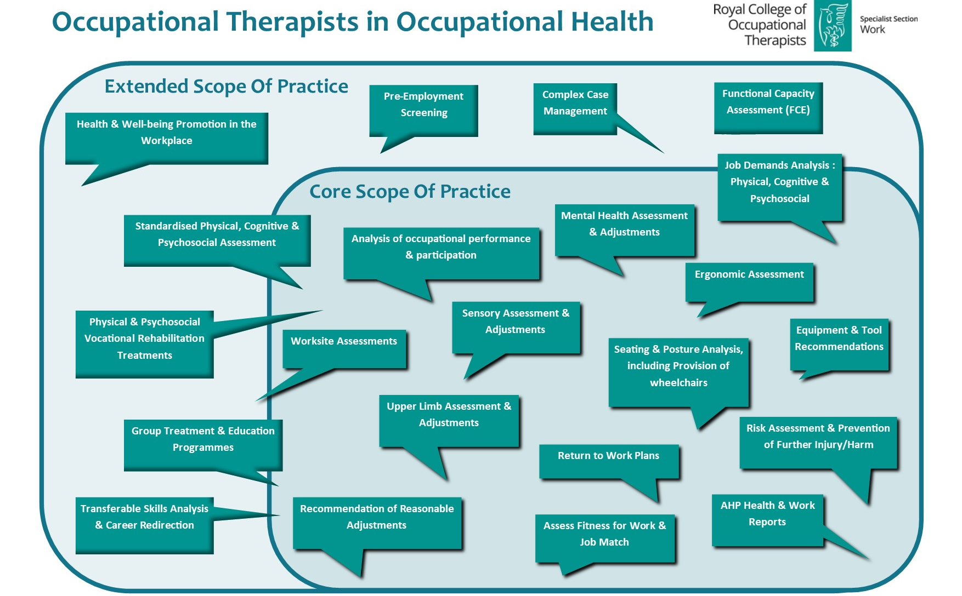
Royal College of Occupational Therapists Specialist Section - Work: https://www.rcot.co.uk/about-us/specialist-sections/work-rcot-ss or rcotsswork@gmail.com
Find an Occupational Therapist? https://www.rcot.co.uk/about-occupational-therapy/find-occupational-therapist

